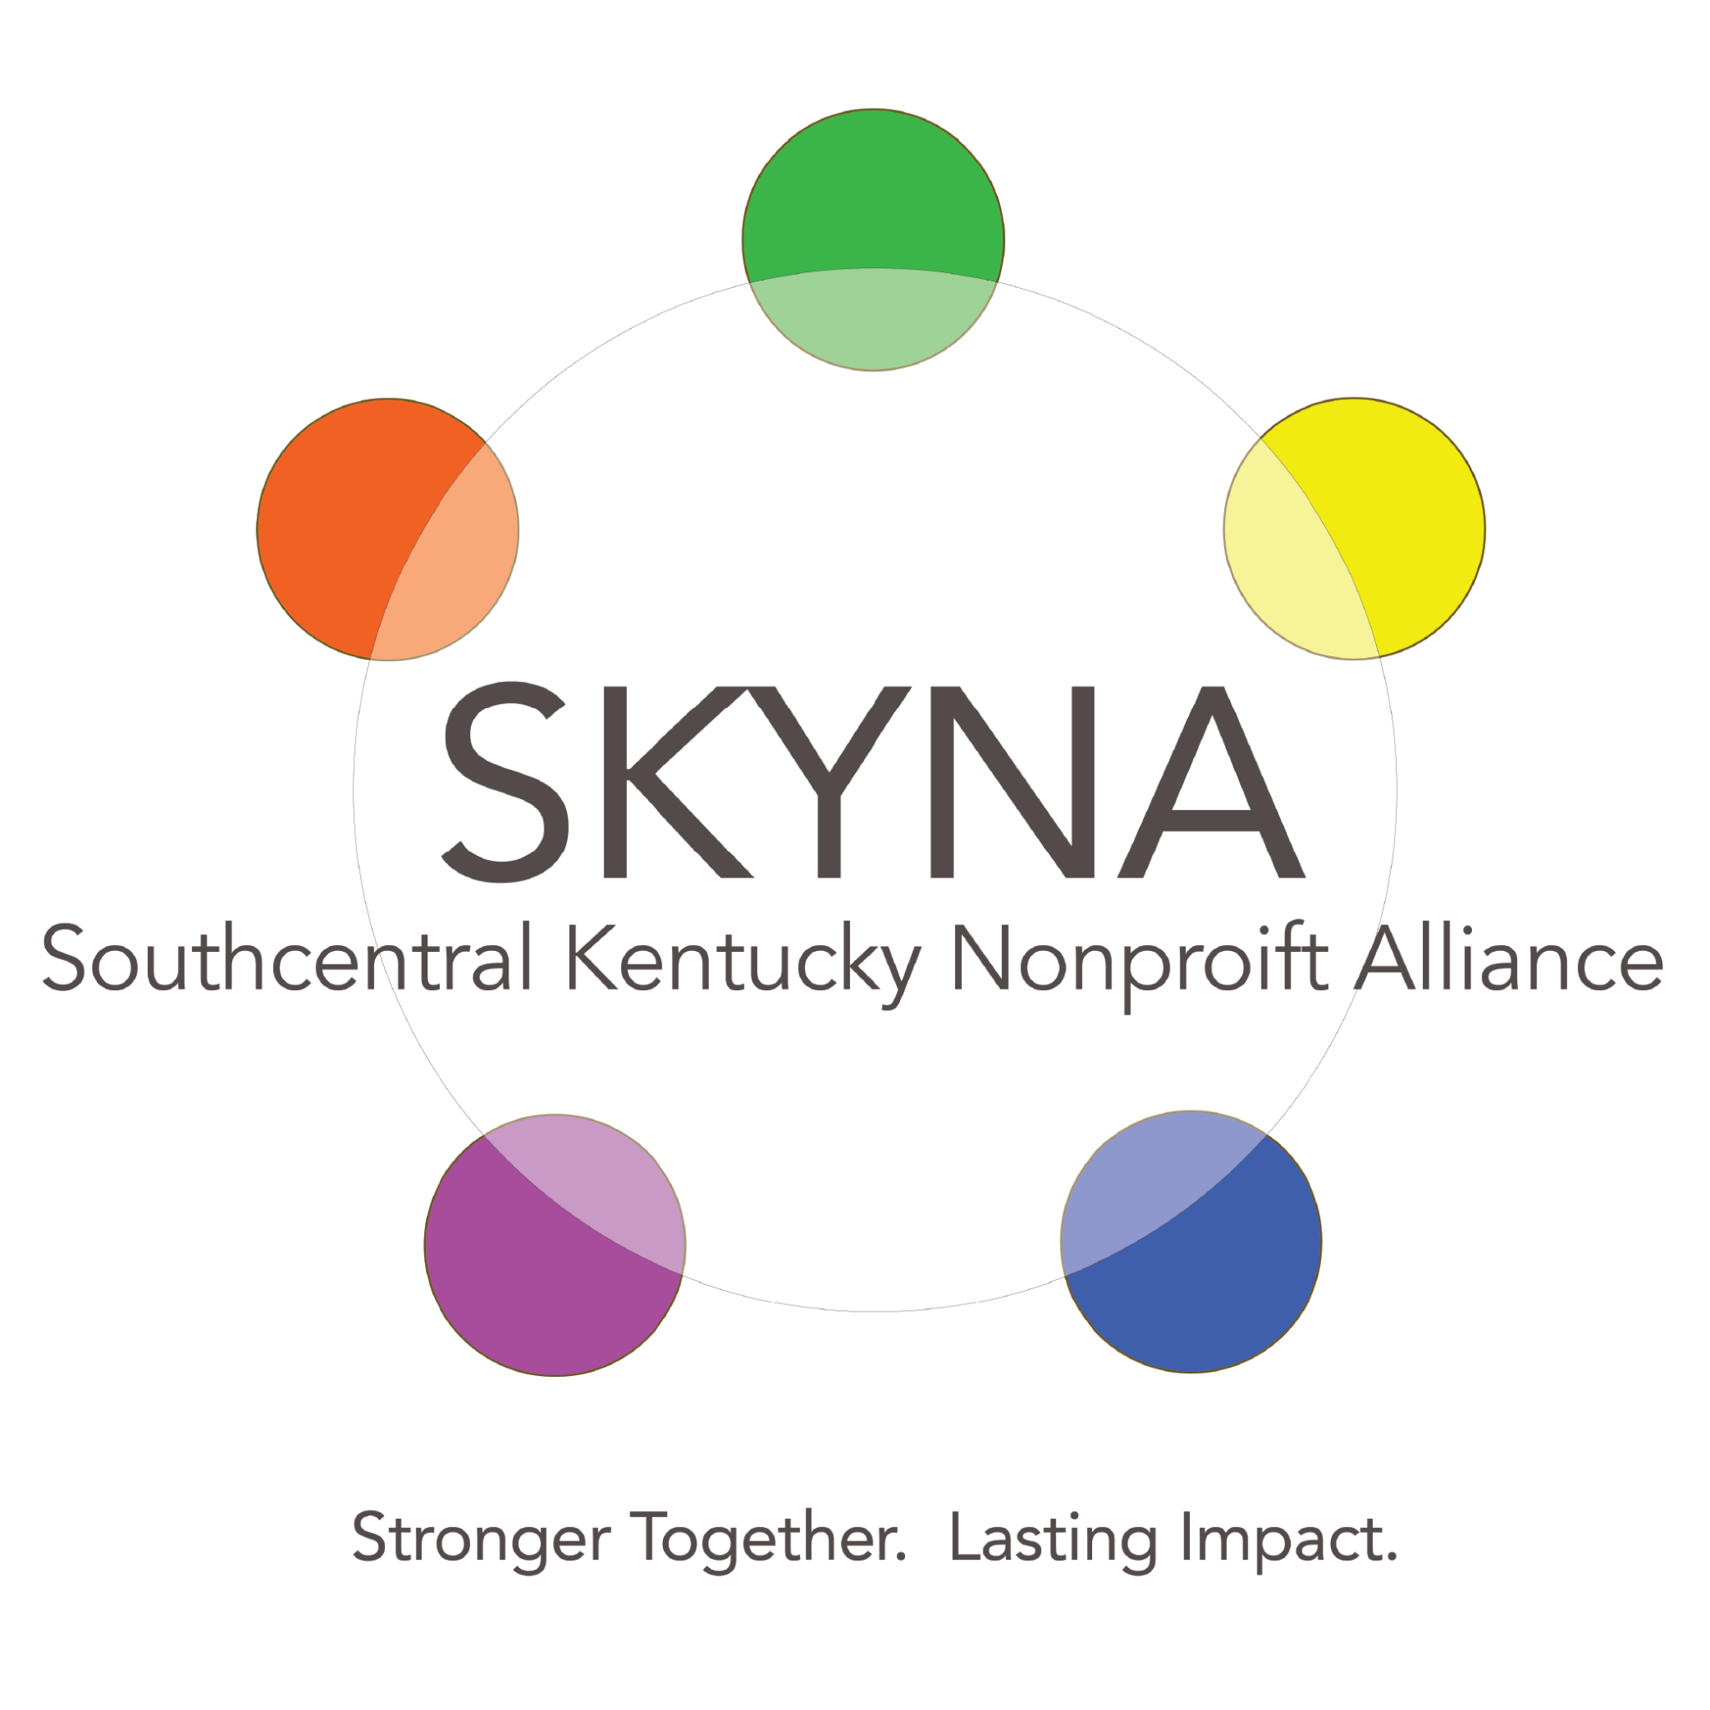

MEMBERSHIP FORM AND COMMITMENT AGREEMENT

Mission Statement: The South Central Kentucky Nonprofit Alliance unites organizations to strengthen community impact through collaboration, resource sharing, and capacity building.

Agency Information

Organization Name: ______________________________

Primary Contact Name: __________________________

Title/Role: _________________________________

Phone Number: ______________________________

Email Address: ______________________________

Website: _________________________________

Organization Address: _______________________
Mission and Programs

Organization’s Mission Statement: ______________________________

Brief Description of Services/Programs Offered: __________________

Target Population Served: _____________________________

Membership Contribution

Please indicate how your organization can contribute to the Alliance's mission:
☐ Volunteer Time
☐ Expertise (please specify areas): _____________________________
☐ Shared Resources (space, equipment, materials, etc.)
☐ Financial Contribution (optional: suggest an annual membership fee)
☐ Collaborative Program Opportunities
☐ Advocacy Support

Preferred Areas of Engagement

☐ Food
☐ Housing/Homelessness
☐ Early childcare and learning
☐ Youth programs
☐ Trauma and Addiction Recovery
☐ Senior Services
☐ Intellectual and Developmental Disability
☐ Arts

Commitment Agreement

By signing this agreement, [Organization Name] affirms its commitment to the shared mission of the South Central Kentucky Nonprofit Alliance. We agree to the following:

1. Mission Alignment: Actively support and promote the shared vision of strengthening community impact.

2. Collaboration: Participate in Alliance meetings, collaborative projects, and joint initiatives.

3. Communication: Maintain transparent and responsive communication with Alliance members.

4. Support: Provide resources or contributions that align with our organization’s capacity and expertise.

5. Ethics and Respect: Uphold ethical practices, mutual respect, and inclusivity within Alliance activities.

Terms of Membership

Membership Duration: (e.g., Annually or ongoing until terminated)

Renewal Process: (e.g., Annual membership review or fee payment, if applicable)

Signatures

On behalf of [Organization Name], I affirm our organization’s commitment to the South Central Kentucky Nonprofit Alliance.

Authorized Signature: ______________________________
Printed Name: ______________________________
Title/Position: ______________________________
Date: ______________________________

For Alliance use only:
☐ Approved
☐ Pending Follow-Up

Alliance Representative Signature: _____________________________
Date: ______________________________

